**Moderate to Severe Evaluation**

Sample_id :**ZRGZT8**

Link:<https://app.animalbiome.com/pet/assessment/report/733e0ea2-52f6-45ed-bb1d-e072a14a37ed>

Cats and dogs:

Any two of the following:

(

High Red Flag Megamonas OR (failed)

High Red Flag Sutterella OR (failed)

High Red Flag Collinsella OR (failed)

Low Red Flag Bacteroides OR (failed)

Low Red Flag Blautia (failed)

);

OR Cats: 8-10 Yellow Flags(Failed)1

OR 5-8 Red Flags;(Failed)1

OR dietary recommendation of increase fiber (Failed)

or protein or decrease carbs(Failed)

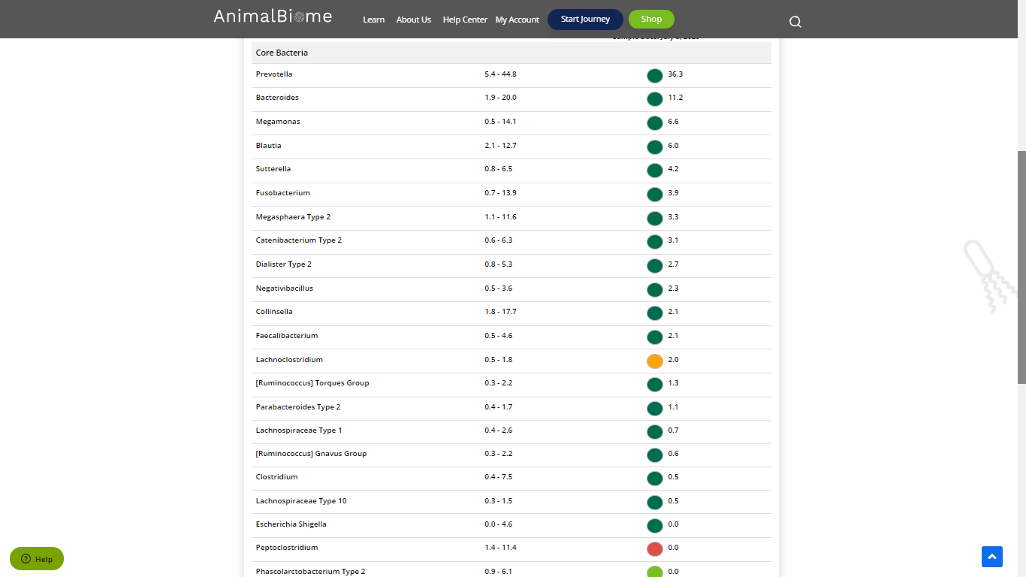

**Low group evaluation:**

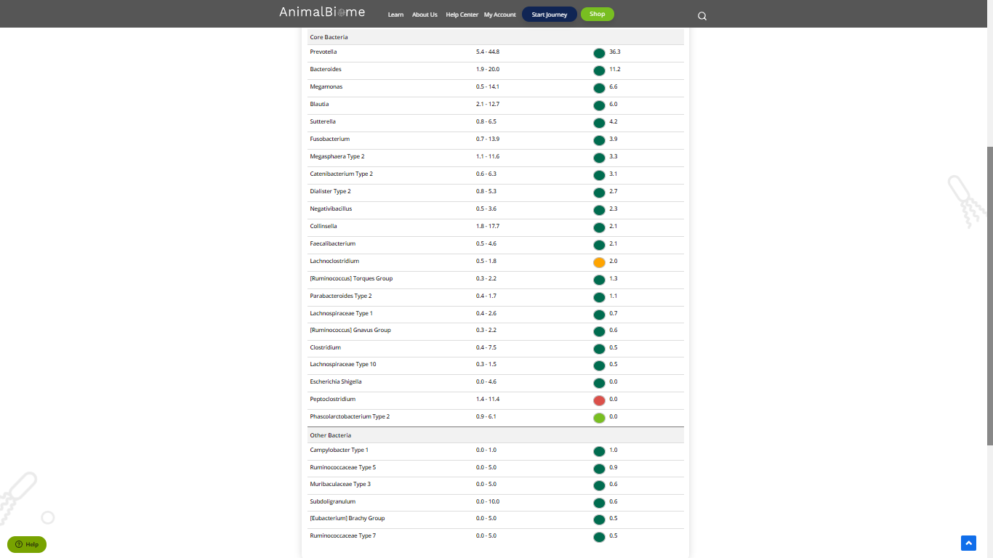

The result : **False False False False**

Mild to moderate evaluation results:fail

**Mild to Moderate evaluation**



Mild to Moderate

Cats and dogs:

Any Two

(High Yellow Flag Megamonas OR (failed)

High Yellow Flag Sutterella OR (failed)

High Yellow Flag Collinsella OR (failed)

Low Yellow Flag Bacteroides OR (failed)

Low Yellow Flag Blautia (failed)

)

OR

Dogs: 4-7 Yellow Flags(failed)

OR 5-7 Red Flags;(failed)

OR Cats and dogs: dietary recommendation of increase fiber or protein or decrease carbs;(failed)

The result : False False False False

Mild to moderate evaluation results:Fail

Expected result : Balanced

Achieved result :**Pass**



